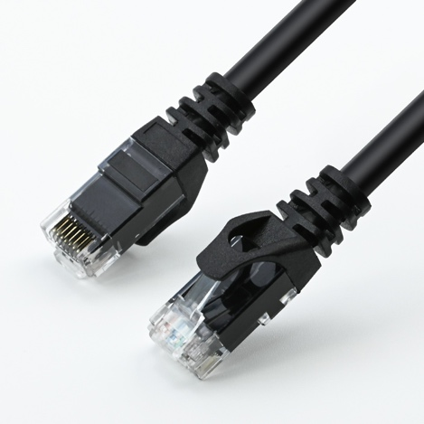
Cat 6A U/UTP Patch Cable, 26 AWG,
Pure Bare Copper

Model: xxx

Main Features:
- Stranded Pure Bare Copper, 26 AWG;
- Supports CAT6A U/UTP bandwidth up to 500 MHz;
- 1U gold-plated contacts for optimized signal integrity;
- 4 Twisted Pairs with filler reduce crosstalk, noise, and interference;
- HDPE Insulation enhances signal integrity and reduces signal loss;
- Fluke Tested for Reliable Performance.

Product Type
Category | Cat 6A
Connector | 2x RJ45 Male (8P8C, 1U Gold Plating)
Shielding | Unshielded (U/UTP)
Conductor
Conductor Type | Stranded
Conductor Material | Pure Bare Copper
Conductor Size | 7/0.16±0.008 mm
Wire Gauge | 26 AWG
Conductor Quantity | 4 Twisted Pairs
Wire Code | 1. Blue / White-Blue  2. Orange / White-Orange  3. Green / White-Green  4. Brown / White-Brown
Insulation
Insulation Material | HDPE
Minimum Average Thickness | 0.12 mm
Outer Diameter | 0.89±0.08 mm
Filler
Material | HDPE
Jacket
Material | PVC
Minimum Average Thickness | 0.51 mm
Outer Diameter | 6.0±0.2 mm
Electrical Properties
Standard Bandwidth | 500 MHz
Input Impedance | 100±15% Ω (@4~100 MHz); 100±22% Ω (@100~250 MHz)
Propagation Delay | ≤ 548 ns/100m
Propagation Skew | ≤ 45 ns/100m
Conductor Resistance | ≤ 149 Ω/km @20°C
Conductor Resistance Unbalance | ≤ 5%
Insulation Resistance | ≥ 5000 MΩ·km
Mechanical Properties
Min. Bending Radius | 8× Cable OD
Environment
Operating Temperature | -15°C to 70°C
Operating Humidity | RH 10% to 90% (non-condensing)
Storage Temperature | -40°C to 80°C
Storage Humidity | RH 5% to 96% (non-condensing)
General
Color | Black
Length | 0.25/0.5/1/2/5/10/20 meter
Diagram | (unit: mm)

